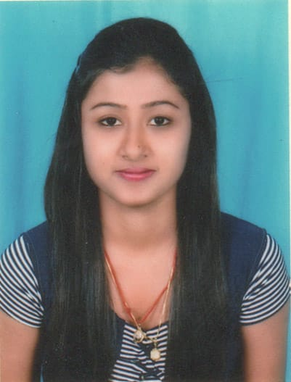

**RESUME**

**ANKITA DASH**

ankitadash888@gmail.com  
+91-7504251235, +91-7978011913

406, 4th Main, Sai Ram Ladies’ PG, KonenaAgrahara, MurgeshPalya, Bangaluru-560017.

**Career Objective**

Toseek challenging avenues where my knowledge and experience matches with the organization's growth.

**EDUCATIONAL QUALIFICATION:**

|  |  |  |  |
| --- | --- | --- | --- |
| M.B.A(Major-Finance, Minor-Marketing) | IBCS, S’O’A University, Bhubaneswar | 2019 | 80 CGPA |
| B.B.A | Institute of Management Advance Global Excellence, Bhubaneswar | 2017 | 67.31% |
| XII(Science), CHSE | Govt. Autonomous College, Anugul | 2014 | 47.5% |
| X, BSC | Govt. Girls’ High School, Anugul | 2012 | 70.7% |

**TECHNICAL SKILLS:**

* Basic language of C.
* MS-Office

**JOB EXPERIENCE:**

EMPLOYER: Indusind bank ltd

JOB DESCRIPTION: Acquisition Manager- Revenue Service Channel

FUNCTION: Sales-unsecured assets(credit cards)

Upgrading the credit cards of existing customers to premium to super premium level.

KEY RESPONSIBLITIES:-

* Deliver assigned Revenue to the Branch
* Deal with ultra HNI customers and understanding their needs and expectations
* Follow and adhere to the strict KYC nnorms

DURATION: 18th February, 2019- 23 February, 2020

**INTERNSHIP PROJECT:**

**Name:** working capital management in Andhra bank  
**Description:** I was analyzing banking financial position. Different companies financial statement in which they appeal for loans.

**PERSONAL QUALITIES:**

* Frank
* Intuitive
* Passionate
* Resourceful

**Extra-Curricular Activities:**

* Classical dance and singing
* In collage life I was anchoring in fest during graduation
* Participate in Scout and Guide camps
* Cooking

**PERSONAL DETAILS**

|  |  |
| --- | --- |
| **Father’s name** | Adv. BibhutiBhusan Dash |
| **Date of birth** | 13th june,1997 |
| **Language known** | English, Odia and Hindi |
| **Address** | Pragati Nagar, kumand, Anugul-759122. |

**DECLARATION:**

I hereby declare that the above written particulars are true to the best of my knowledge and belief.

PLACE: Bengaluru DATE: